HANA SQL

Содержание

APPLY_FILTER
STRING_AGG
RegExpr
CROSS APPLY
RollUp

Сумма с нарастающим итогом

LEAD & LAG

Roll_Number – убираем повторяющиеся значения
Вызов CV с параметрами

How to debug SAP HANA SQLScript in AMDP-Transformations

Select from CV | Table function

select top 1000 * from "_SYS_BIC"."package_01/CV_GROSS_INC_ON_LC"
select top 1000 * from "EKIMENKO"."package_01::tf_gross_income_on_lc" ('01.07.2021', '2021-12-31', '2022-01-01', '2022-03-30')

APPLY_FILTER is SQL function, which allows creating dynamic filter on a table. Syntax of the function is following -

APPLY_FILTER(<table_or_table_variable>, <filter_variable_name>);

TF с двумя параметрами -

FUNCTION "EKIMENKO"."package_01::tf_dummy"
(emit VARCHAR(5000), azs_ varchar(5000))
RETURNS TABLE
(
"BEMIT000" VARCHAR(10),
"CODE" VARCHAR(10),
"BAZS0000" varchar(10)
)
LANGUAGE SQLSCRIPT
SQL SECURITY INVOKER
default schema "SAPABAP1"
AS
BEGIN
-- declare filter varchar(5000):= ' "BEMIT000" in (' || :emit || ')';
declare filter varchar(5000);
select
case
when (:emit = '' and :azs_ = '') then '1=1'
when (:emit = '' and :azs_ <> '') then ' "BAZS0000" in (' || :azs_ || ')';
when (:emit <> '' and :azs_ = '') then ' "BEMIT000" in (' || :emit || ')';
when (:emit <> '' and :azs_ <> '') then
' "BEMIT000" in (' || :emit || ') and "BAZS0000" in (' || :azs_ || ')'
end into filter from dummy;
azs =
SELECT
"/BIC/BEMIT000" as BEMIT000,
CODE,
"/BIC/BAZS0000" as BAZS0000
from "/BIC/ABDAZS0002";
filtered_azs = apply_filter(:azs, :filter);
return
select
BEMIT000,
CODE,
BAZS0000
from :filtered_azs;
END;

STRING_AGG("/BIC/BNOM0000", ';')

Содержание

Пример
Агрегирование номенклатур в разрезе чеков

SELECT "/BIC/BCHKNUM0",
STRING_AGG("/BIC/BNOM0000", ';') AS STR
FROM "/BIC/ABDSLS0002"
Where CALYEAR=2019 And CALMONTH2=07
GROUP BY "/BIC/BCHKNUM0"

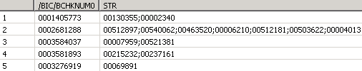

RegExpr

select replace_regexpr('([[:space:]]+)' in 'Агеева Галина Владимировна' with ' ' occurrence all) from dummy;

replace_regexpr('(^[0]+)' in sls."/BIC/BCRDNUM0" with '' occurrence all)

select case when '#ДЕЛ/0!' LIKE_REGEXPR '^.*(\w+)' then 1 else 0 end from dummy

The following example uses a regular expression to replace date format 2014-04-01 with the value 01/04/2014:

SELECT REPLACE_REGEXPR('([[:digit:]]{4})-([[:digit:]]{2})-([[:digit:]]{2})' IN '2014-04-01'
WITH '\3/\2/\1' OCCURRENCE ALL) "replace_regexpr" FROM DUMMY;

18.03.2023 00:01:23.000 { cm_status : ready , is_rinsing : true, timestamp : 1679086883}
([[:digit:]]{2}.[[:digit:]]{2}.[[:digit:]]{4})

CROSS APPLY
Содержание

HANA SQL join alternatives to CROSS APPLY / LATERAL
https://stackoverflow.com/questions/63828504/hana-sql-join-alternatives-to-cross-apply-lateral

− Here's a sample of the alternative to CROSS APPLY - but the performance appears to have become poor and I am getting out of memory errors.

SELECT * FROM SAPECC.AUFK AS AUFK
LEFT OUTER JOIN
(SELECT *,
ROW_NUMBER() OVER (PARTITION BY MANDT, OBJNR ORDER BY UDATE DESC ) AS
RowNumber
FROM SAPECC.JCDS
WHERE STAT = 'I0045' AND INACT = ''
) JCDS
ON JCDS.OBJNR = AUFK.OBJNR AND JCDS.MANDT = AUFK.MANDT AND
JCDS.RowNumber = 1

− You might try a correlated subquery instead of ROW_NUMBER() - this query should take advantage of an index on (objnr, mandt, stat, inact, udate desc).
select * from sapecc.aufk as aufk
left join sapecc.jcds as jcds
on jcds.objnr = aufk.objnr and
jcds.mandt = aufk.mandt and
jcds.stat = 'I0045' and
jcds.inact = '' and
jcds.udate =
(select max(jcds1.udate) from sapecc.jcds as jcds1
where jcds1.objnr = aufk.objnr
and jcds1.mandt = aufk.mandt
and jcds1.stat = 'I0045'
and jcds1.inact = ''
)

− You could use the same CTE /common table expressions)/ approach that you're used from MSSQL with HANA

WITH most_recent_JCDS as (
SELECT * FROM (
SELECT *,
ROW_NUMBER() OVER (PARTITION BY MANDT,
OBJNR ORDER BY UDATE DESC) AS RowNumber
FROM SAPECC.JCDS
WHERE STAT = 'I0045' AND INACT = '')
WHERE
RowNumber = 1)

SELECT
AUFK. ...
, JCDS. ...

FROM
SAPECC.AUFK AUFK
LEFT OUTER JOIN most_recent_JCDS JCDS
ON
(JCDS.OBJNR, JCDS.MANDT)
= (AUFK.OBJNR, AUFK.MANDT);

LEFT OUTER JOIN LATERAL
SELECT TA.a1, TB.b1 FROM TA, LATERAL (SELECT b1, b2 FROM TB WHERE b3 = TA.a3) TB WHERE TA.a2 = TB.b2;

My

Плотности в hana
select top 1000
inTab."/BIC/BEMIT000", inTab."/BIC/BAZS0000", inTab."/BIC/BNP00005", inTab.date0,
inc_."/BIC/BSDNSTY0"
from "/BIC/ABDNPSPD2" as inTab
left outer join "/BIC/ABDNPINC02" as inc_
on inc_."/BIC/BEMIT000" = inTab."/BIC/BEMIT000" and
inc_."/BIC/BNP00005" = inTab."/BIC/BNP00005" and
inc_."/BIC/BAZS0000" = inTab."/BIC/BAZS0000" and
inc_.date0 in
(select max(date0) from "/BIC/ABDNPINC02"
where "/BIC/BEMIT000" = inTab."/BIC/BEMIT000" and
"/BIC/BNP00005" = inTab."/BIC/BNP00005" and
inc_."/BIC/BAZS0000" = inTab."/BIC/BAZS0000" and
date0 <= inTab.date0 and "TIME" <=inTab."TIME"
)
where year(inTab.date0)=2021

Плотности в mssql
case when sales.Density > 0 then sales.Density else dn.Density end as Density,

outer apply
(select max(DateStart) as DateStart, Id, AVG(Density) as Density from dbo.AzsInDensity_on_date
where EmitterCode = sales.AzsDocOrganizationCodeEmitent and Id = sales.FuelCode and DateStart <= sales.date
group by Id
) as dn

Nearest date value
https://stackoverflow.com/questions/47028803/nearest-date-value

from
http://teachmehana.com/create-sap-hana-table-sql-script-method/

CREATE COLUMN TABLE "EKIMENKO"."T_KPI_01"
(KPI_CODE NVARCHAR(3), --NOT NULL ,
BEMIT000 NVARCHAR(8),
TXTSH VARCHAR(20),
TXTLG_2 VARCHAR(1333),
BNPCNT00_PR DECIMAL(18,4),
BNPCNT00_CUR DECIMAL(18,4),
CALMONTH_CUR NVARCHAR(2)--,
--PRIMARY KEY (CUST_ID)
)
;

create column table "EKIMENKO"."KPI_01" as
(select * from "_SYS_BIC"."RetailAzs.KPI/CV_KPI_01" )

delete from "EKIMENKO"."KPI_01"

insert into "EKIMENKO"."KPI_01"
(select * from "_SYS_BIC"."RetailAzs.KPI/CV_KPI_01" )

EKIMENKO is invalid only transparent database tables, views, or database procedures can be specified after USING

Questions on CDS Views with input parameters
https://answers.sap.com/questions/11473724/questions-on-cds-views-with-input-parameters.html

GRANT CREATE ANY ON SCHEMA EKIMENKO TO _SYS_REPO WITH GRANT OPTION
GRANT INSERT ON SCHEMA EKIMENKO TO _SYS_REPO WITH GRANT OPTION

Insufficient privilege Detailed info for this error can be found with quid 904B57F72239924AAC956FA883E9CDDB

When using SAP HANA studio, open the SQL Console and execute /using GUID from your initial message, update as appropriate/
CALL SYS.GET_INSUFFICIENT_PRIVILEGE_ERROR_DETAILS ('904B57F72239924AAC956FA883E9CDDB', ?)

Amdp insert data in hana table from calculation view

RollUp
Содержание

select customer, year, sum(sales)
from t1
group by ROLLUP(customer, year);

select customer, year, sum(sales)
from t1
group by grouping sets
(
(customer, year),
(customer)
)
union all
select NULL, NULL, sum(sales)
from t1;

Сумма с нарастающим итогом
Содержание

from https://www.hanaexam.com/2016/07/cumulative-sum-running-total-in-hana.html

Вариант 1
select a."Month", a."Amount", (select sum(b."Amount") from "<SCHEMA>"."RUN_SUM" b where a."Month" >= b."Month" ) as run_sum
from "<SCHEMA>"."RUN_SUM" a
order by a."Month"

Вариант 2
select "Month" , "Amount" , Sum("Amount") over ( order by "Month")
from "<SCHEMA>"."RUN_SUM"
order by "Month"

Вариант 3
SELECT CALMONTH , ORDER_QUAN ,
SUM (ORDER_QUAN) OVER ( PARTITION BY CALMONTH ORDER BY CALMONTH) AS SUM_VAL
FROM
( SELECT CALMONTH , SUM(ORDER_QUAN) AS "ORDER_QUAN"
FROM "MY_TABLE"
WHERE CALMONTH BETWEEN '201401' AND '201603'
GROUP BY CALMONTH
)

LEAD & LAG
Содержание

LEAD – следующее значение столбца

LEAD(t_sts.txtlg) OVER(PARTITION BY cf_st."/BIC/BCF_DVC0", cf_st.CALDAY ORDER BY to_timestamp(concat(cf_st.CALDAY, cf_st.TIME), 'YYYYMMDDHH24MISS')) as Lead

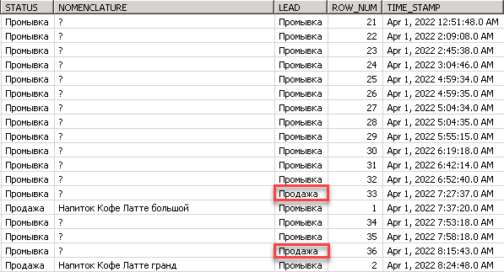

LAG – предыдущее значение столбца

Roll_Number – убираем повторяющиеся значения
Содержание

ROW_NUMBER() OVER (PARTITION BY cf_st."/BIC/BCF_DVC0", cf_st.CALDAY, t_sts.txtlg ORDER BY t_sts.txtlg) AS row_num, t_nom.txtlg as Nomenclature

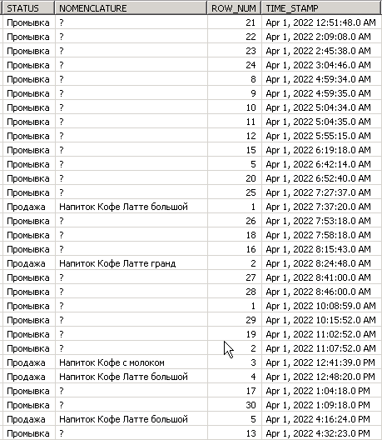

Вызов CV с параметрами

Содержание

select top 1000 *
from "_SYS_BIC"."RetailAzs/CV_ACTIONS_CHK_CNT_P"
('PLACEHOLDER' = ('$$FROM_$$', '20230801'), 'PLACEHOLDER' = ('$$TO_$$', '20230810'))

How to debug SAP HANA SQLScript in AMDP-Transformations

https://www.nextlytics.com/blog/debug-sap-hana-sql-script-in-amdp-transformations
Содержание

